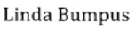
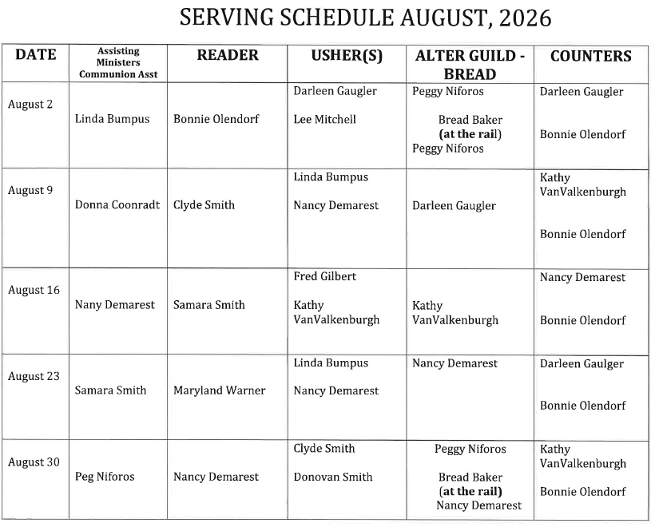
UPDATED
Kathy VanValkenburgh
Peg Niforos

