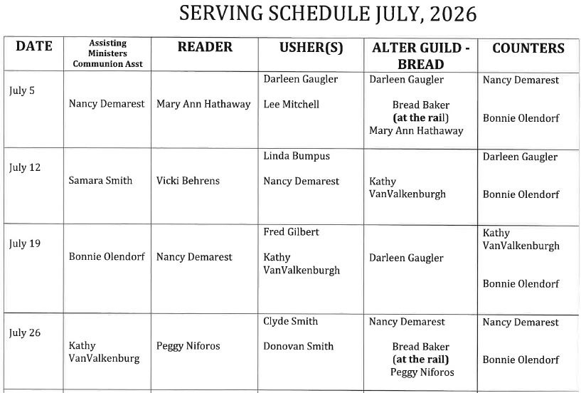
UPDATED
Maryland Warner

Peg Niforos
Kathy VanValkenburgh

